

TEMENOS T24

Stream

User Guide

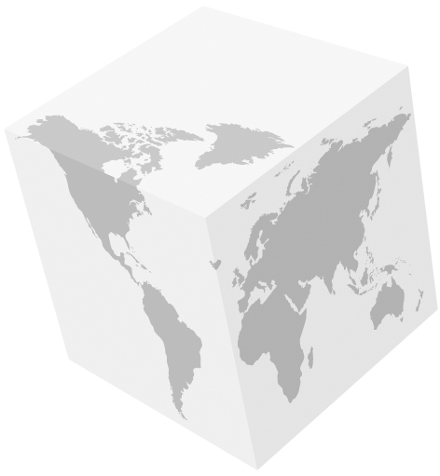Table of Contents

Google Drive Widget and Code

Introduction 3

Preface 3

Overview 3

Assumptions 3

Getting Started 3

Installation 3

Adding Google Drive Widget 4

# 

# Introduction

## Preface

This User Guide is intended for Developers and provides the step by step instructions for adding a Google Drive widget, in your presentation.

## Overview

The Google Drive's widget allows users to share files and folders from their google Drive account within a web site (see the following image – list view).

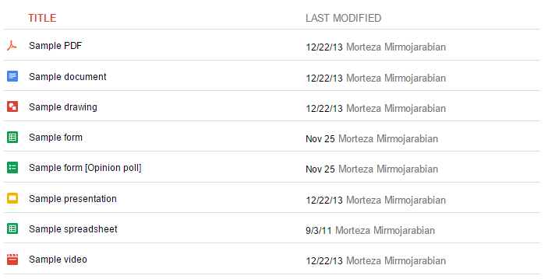

## Assumptions

It is assumed that you are familiar with the edgeConnect Editors and have working knowledge on edgeConnect.

# Getting Started

## Installation

For manual installation:

1. Copy **com.temenos.widgets.google.drive** folder in your widgets folder (Ex: /{your project/templates }).
2. Restart IDE.

For auto-installation:

1. Run IDE.
2. Make sure the ‘**Switch Monitor on/off’** is checked.
3. Download and copy the widget **com.temenos.widgets.google.drive.zip** to the monitored folder.

(Navigate to **Tools** -> **Options** -> **Auto-install** tab and set in **Download Location** the folder where you copied the widgets.) There is no need to restart IDE.

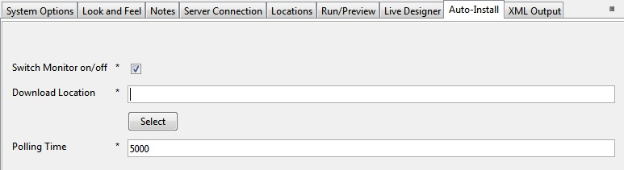

## Adding Google Drive Widget

To add a Google drive widget:

1. You have to insert a new display Item of **Google Drive** type, in the **Presentation Editor**.
2. Within the **Widget Details** tab, you have to set up the widget settings.

**Folder ID** - The identifier of your Google Drive Folder. To obtain the ID of a folder, perform the following steps:

Go to Google Drive Website >> open the folder >> look at its URL in the address bar of your browser. For example:

Folder URL: https://drive.google.com/#folders/**0B1iqp0kGPjWsNDg5NWFlZjEtN2IwZC00NmZiLWE3MjktYTE2ZjZjNTZiMDY2**

You could extract Folder ID from the Folder URL:

Folder ID: **0B1iqp0kGPjWsNDg5NWFlZjEtN2IwZC00NmZiLWE3MjktYTE2ZjZjNTZiMDY2**

This folder can be accessed by the other users only if it has permission that allows for access (either by the public or for private use). For more details about sharing settings, refer to the following URLs:

<https://support.google.com/drive/answer/2494886?hl=en>

<https://support.google.com/drive/answer/2494822>

* **List** - Google Drive folders can be embedded and displayed in list and grid views.
* **Width -** The width of the widget
* **Height –** The height of the widget

